**ASSIGNMENT - 2**

**DATA ANALYTICS**

**EXPLORATION AND VISUALIZATION OF**

**DATASET**

NAME: JAGATHEESWARAN.R

REG NO: 611020106012

# 

**QUESTION:**

Upload the dataset to cognos Analytics,prepare the data,explore and Create Interactive Dashboard,report and story.

**PROBLEM DESCRIPTION:**

**Dataset:50_Startups.csv** https:www.Kaggle.com/datasets/rhuebher/human-resource-data-set

**About the 50 startups dataset**

HR data be hard to come by,and HR professional generally lag behind with respect respective analytics and data visualization competency . We use the data set to teach HR students how to use and analysis in the data in cognosa data visualization tool that’s easy to learn.

This version provides a variety of features that are useful to both data visualization AND creating machine learning/predictive analysis model. We are working on expanding the data set even further by generating even more records and a few additional features we will be keeping these as one file/one data set for now. There is a possibility for creating a second file perhaps down the road where you can join the files together to practice IBMDB2/joins.etc.

Note that this data set isn’t perfect By design, there are some issues that are present, It is primarily designed as a teaching data set-to teach human resources professional how to work with data and analytics.

## EXPLORATIONS

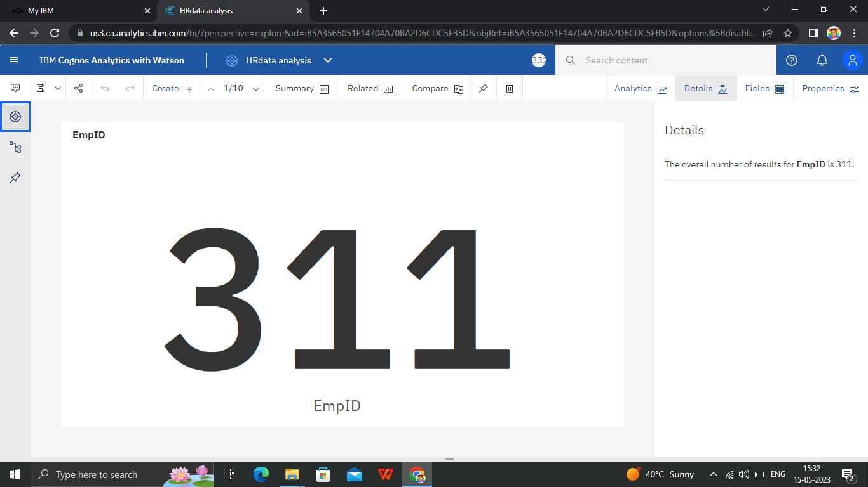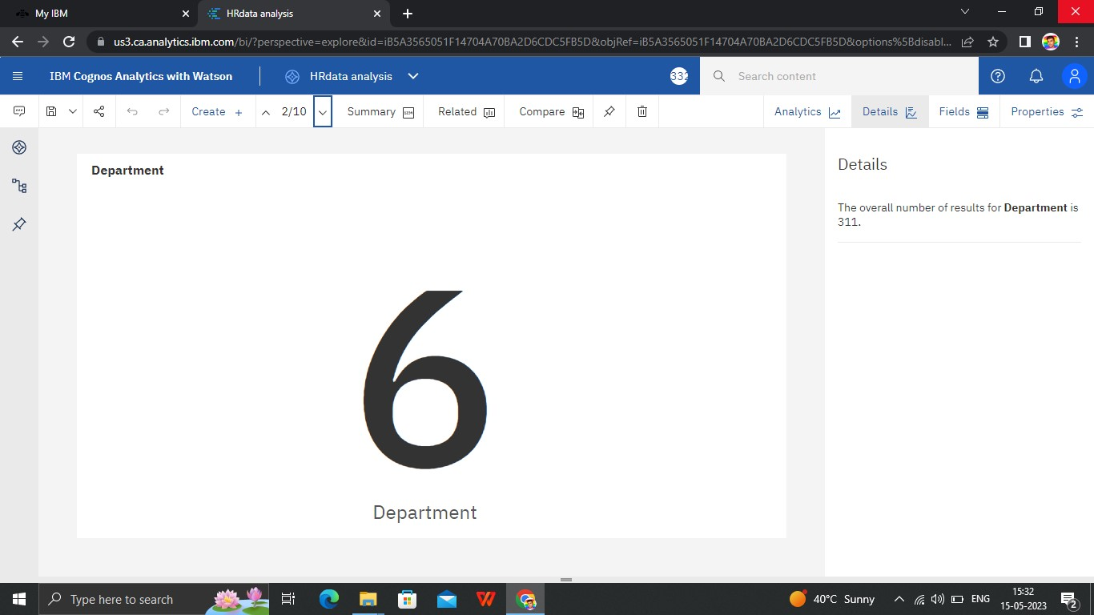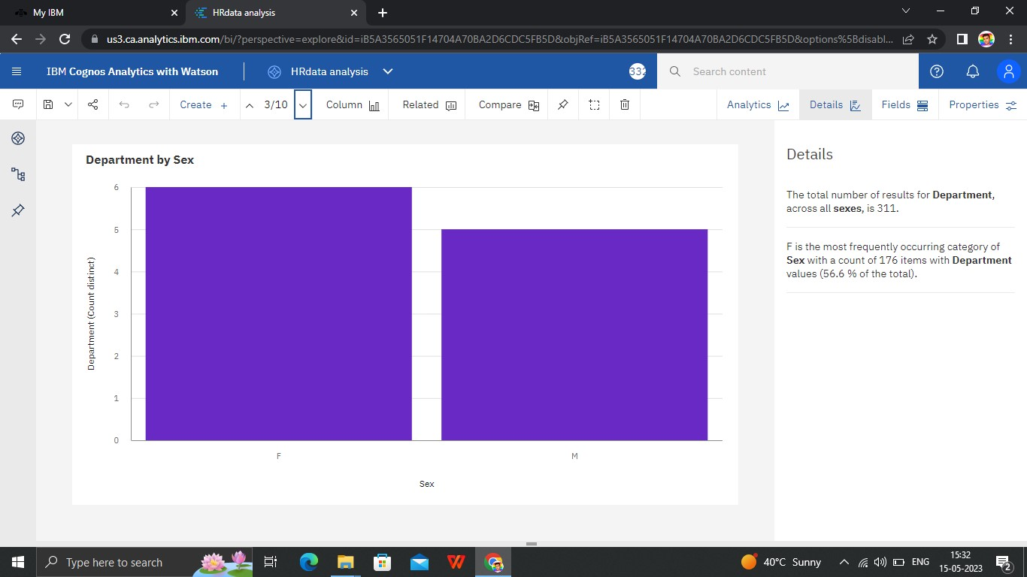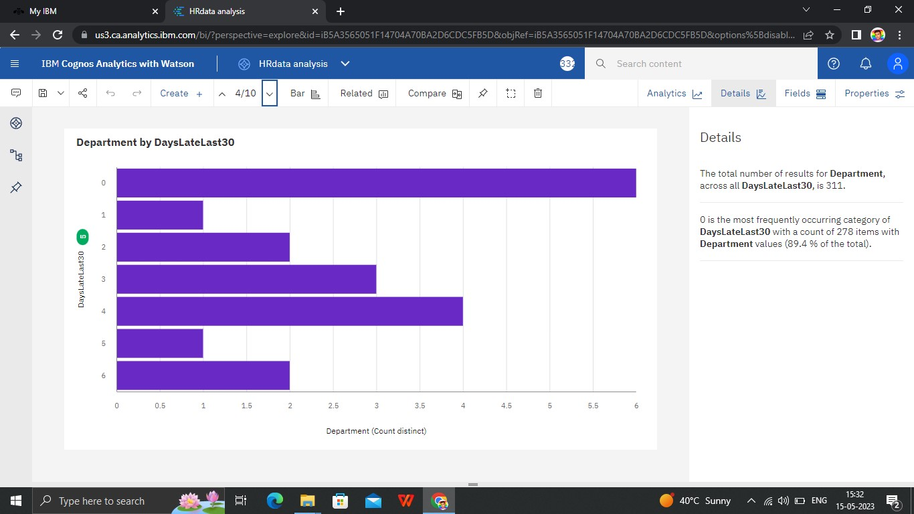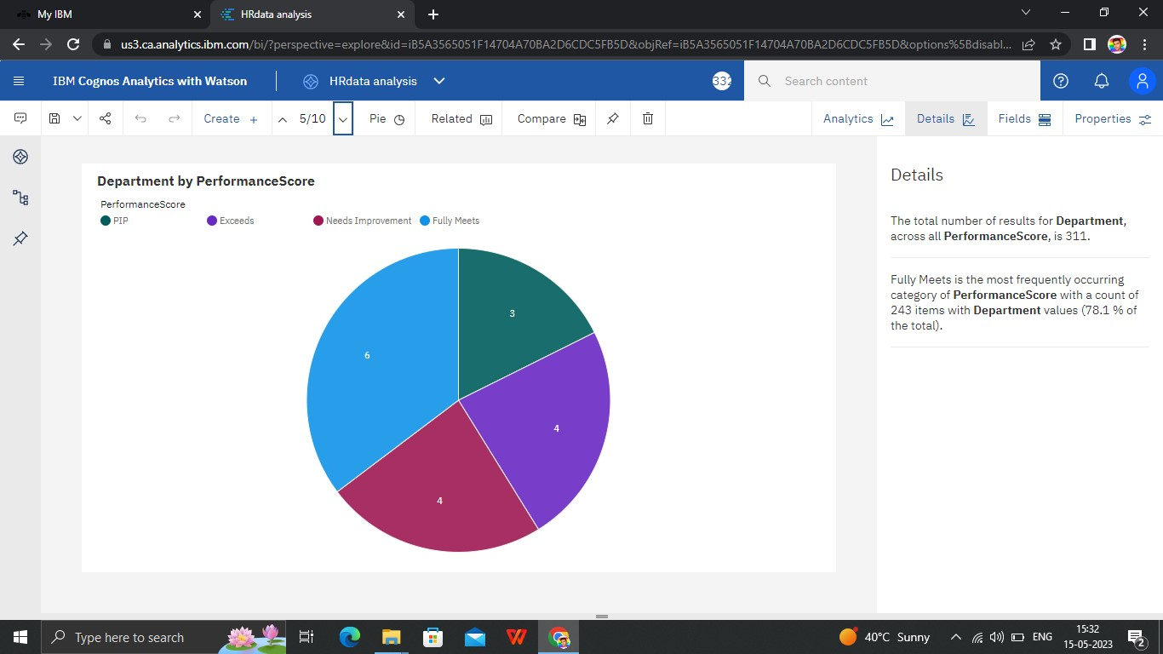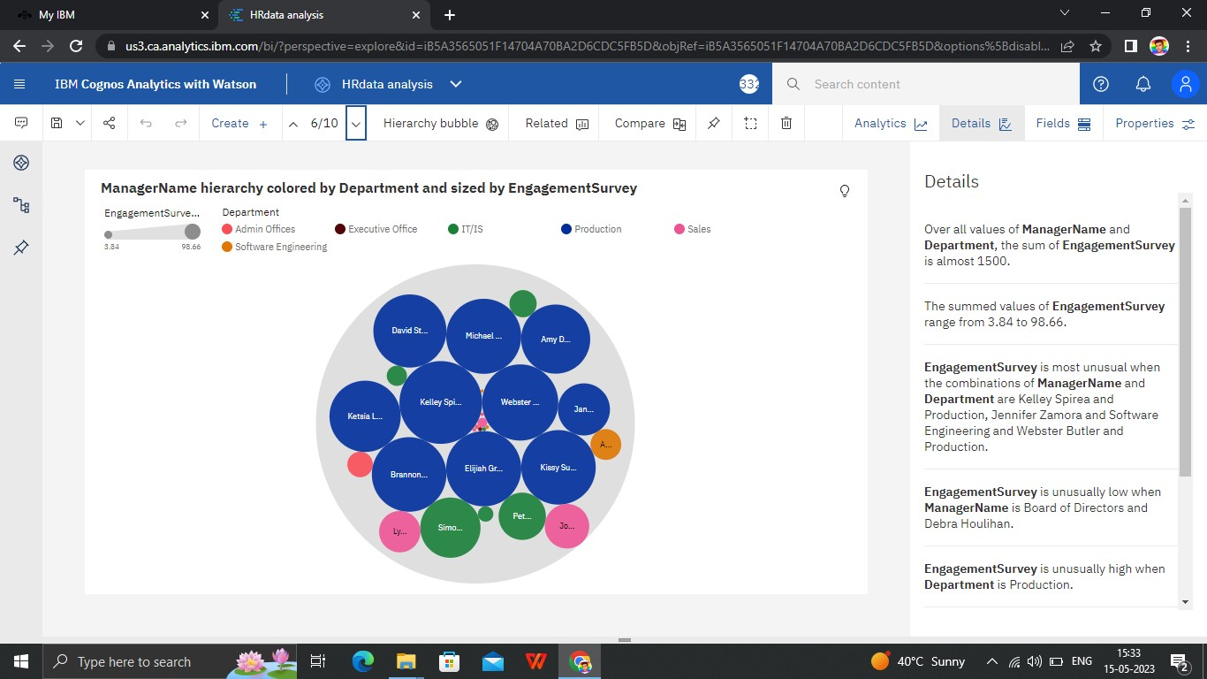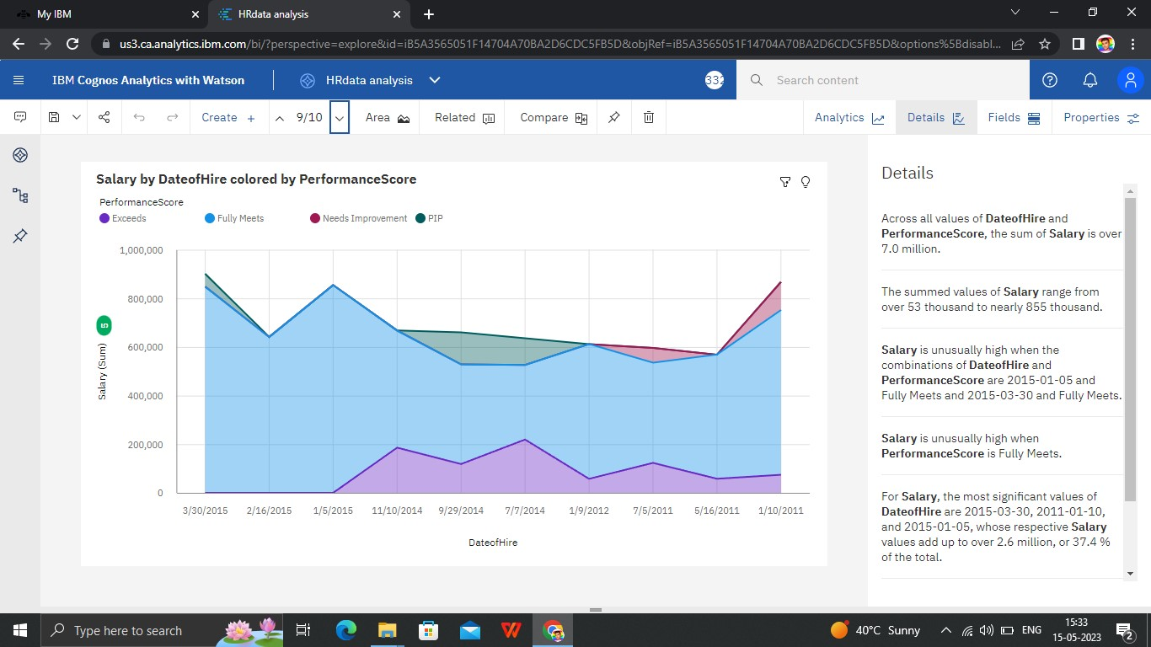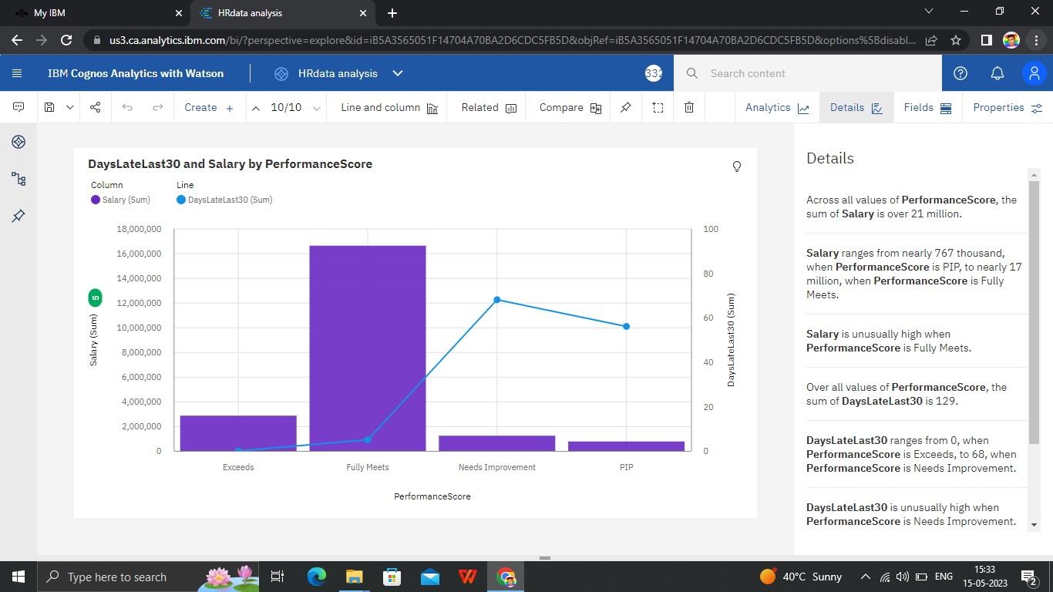

# DASHBOARD

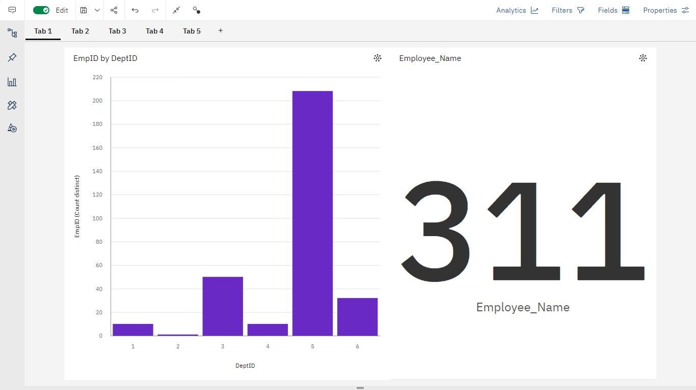

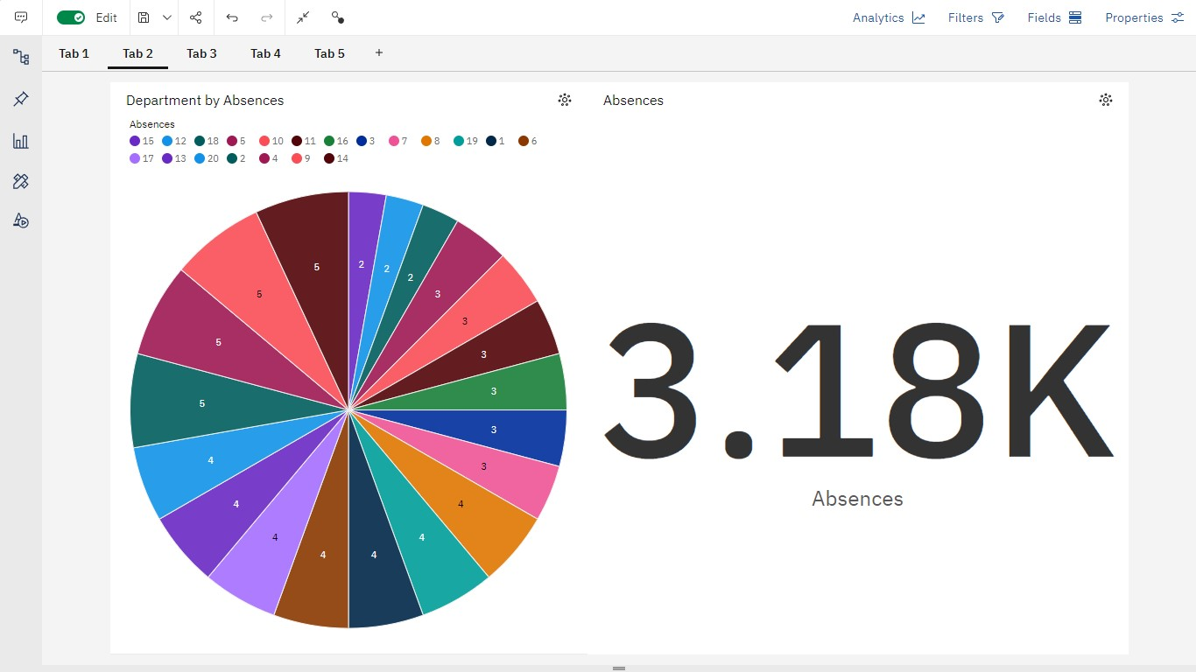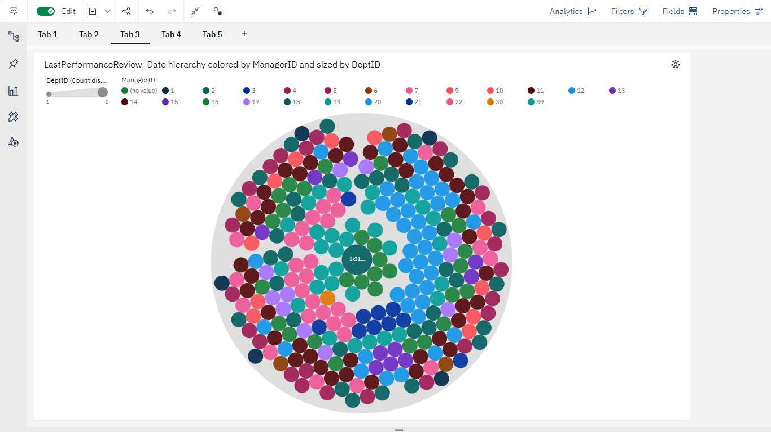

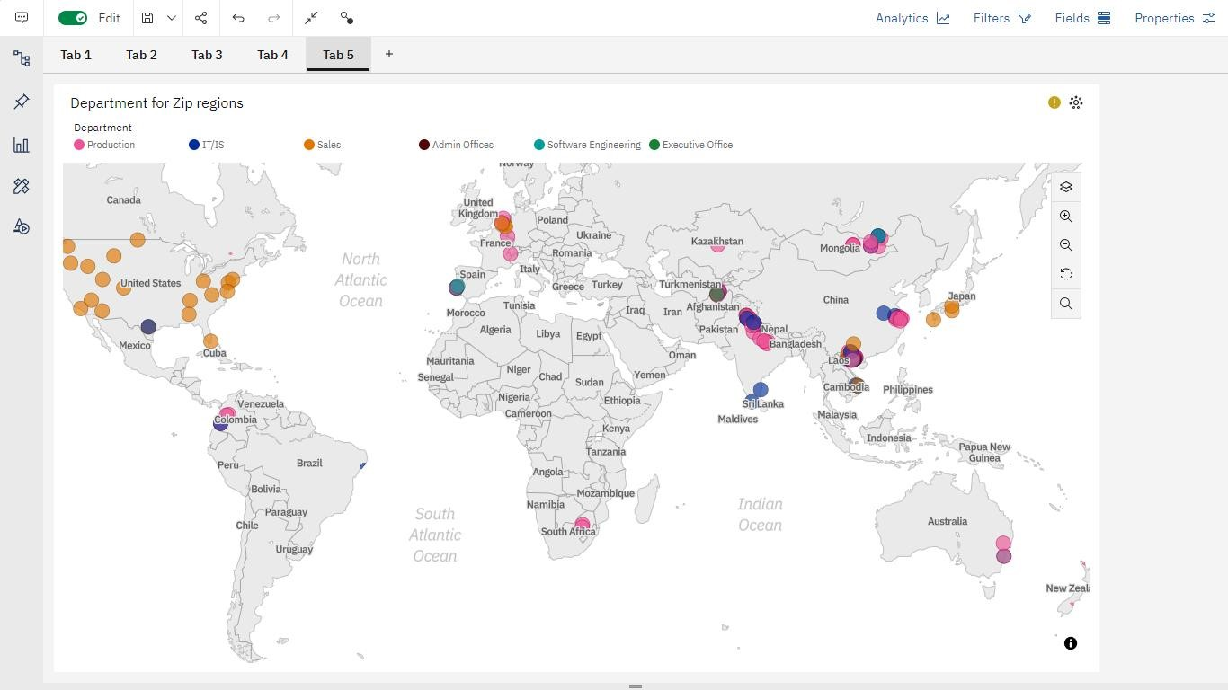

## REPORT

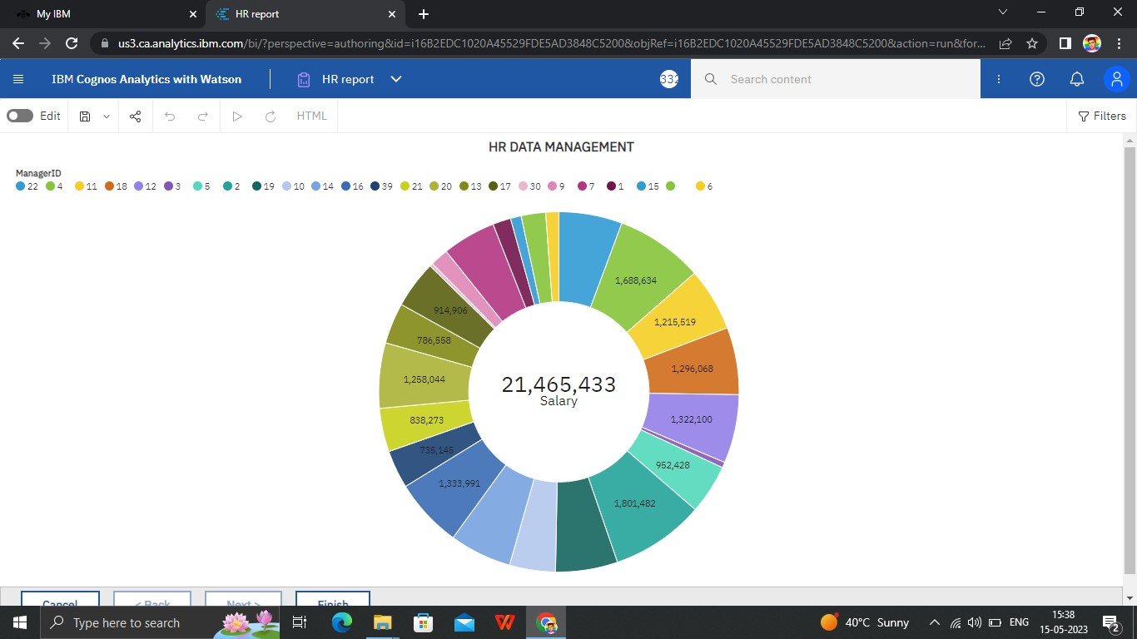

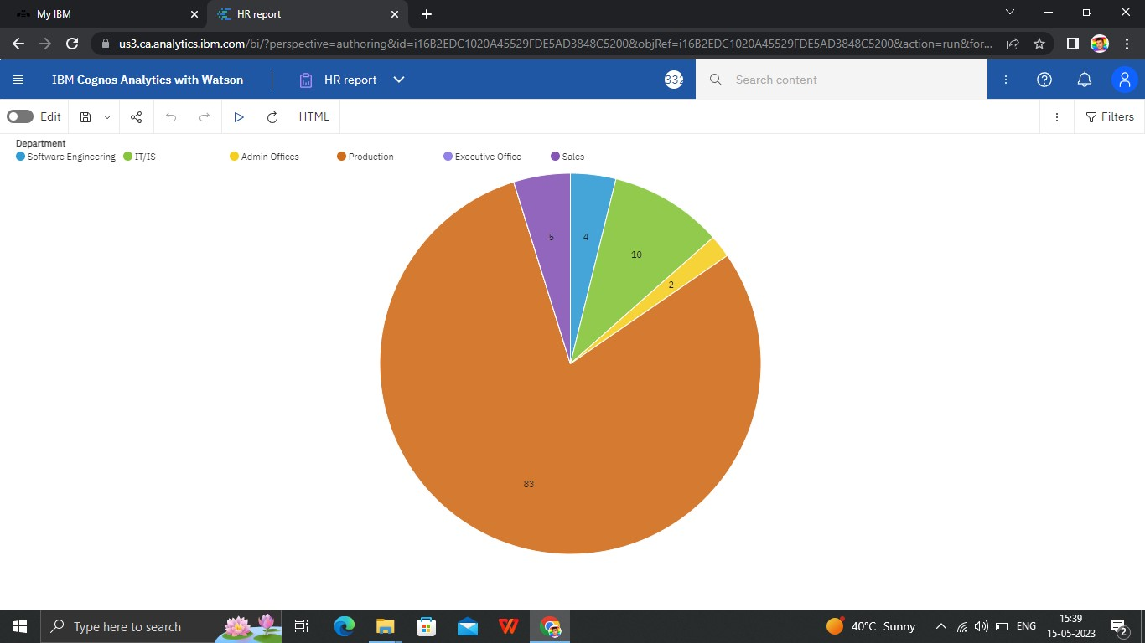

## STORY

